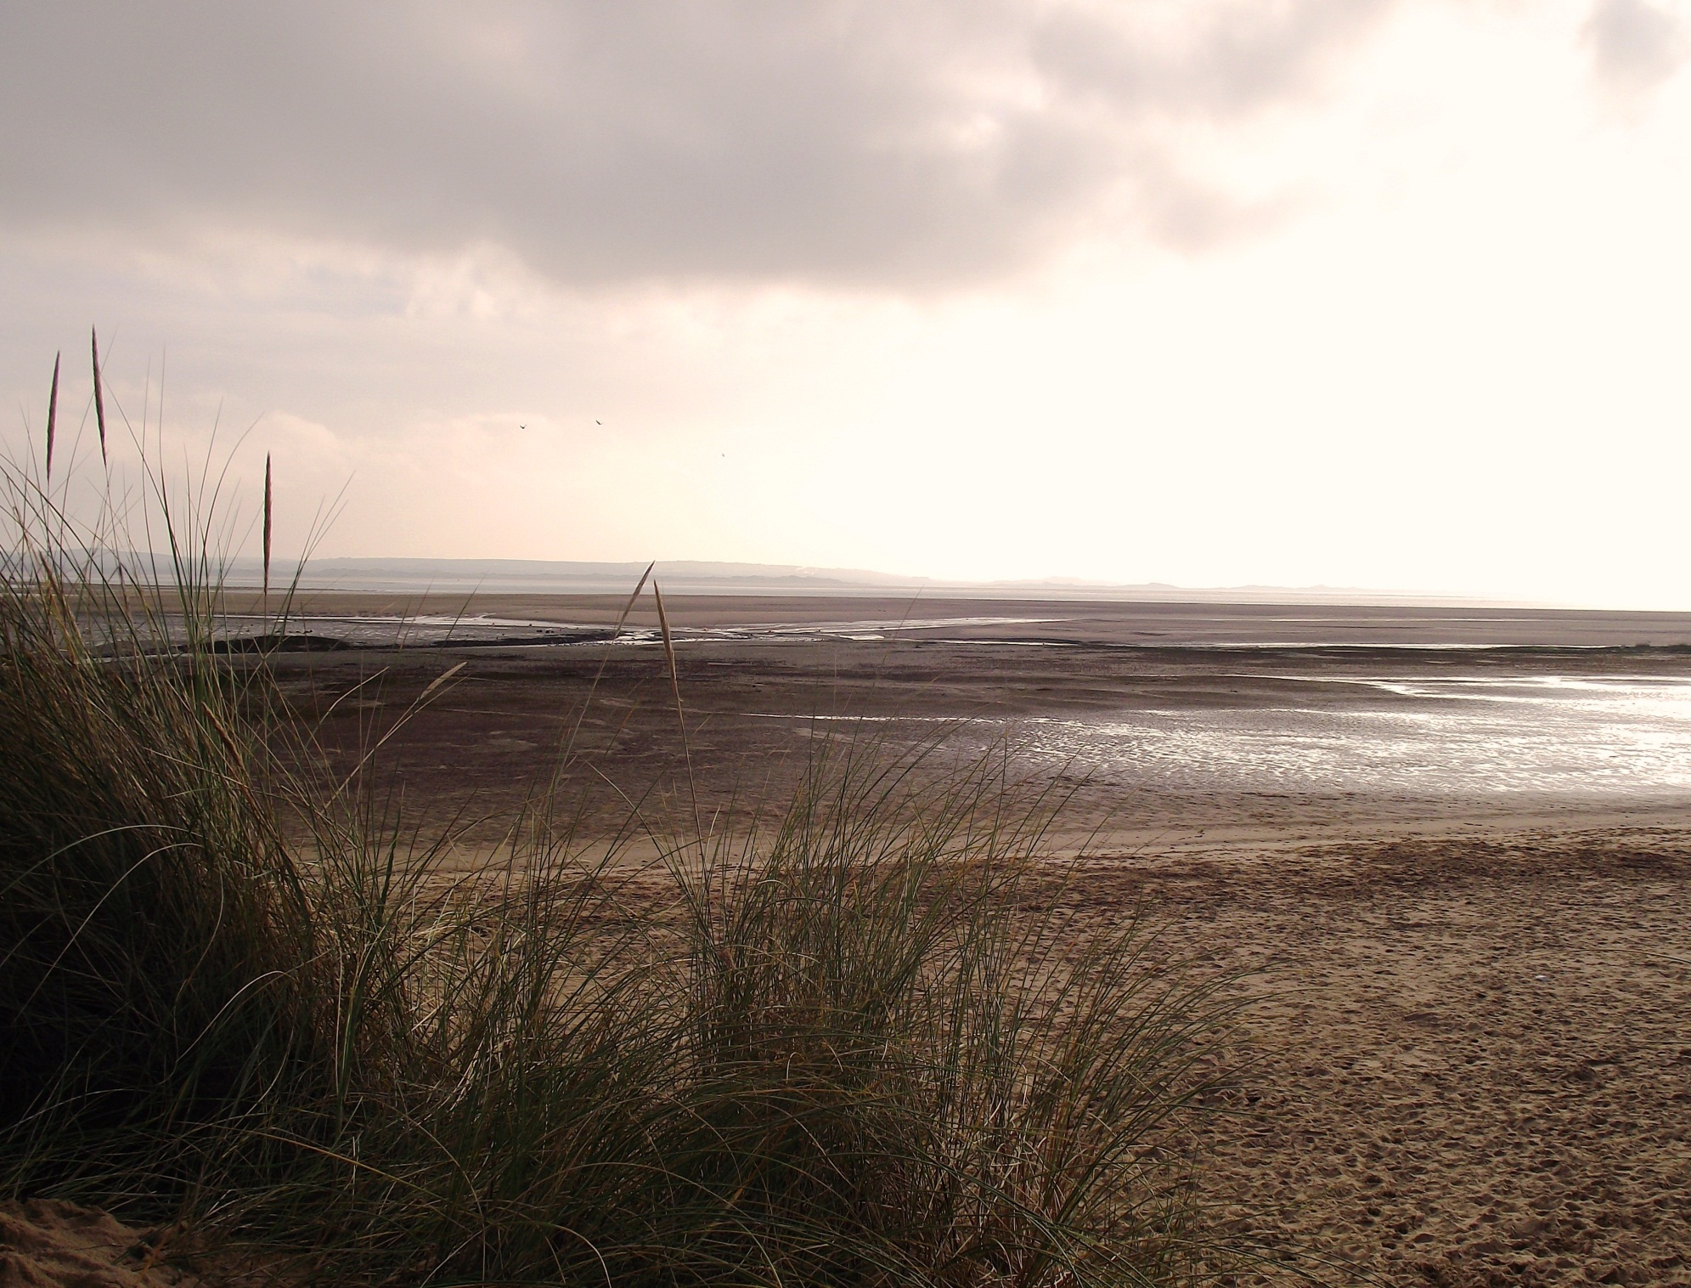



You are cordially invited to the

Copeland Coastal Partnership Conference

Thursday 19th March 2015
2pm – 6pm

The Old Laundry Room, Muncaster Castle

The conference will provide the opportunity to look back at the achievements of the partnership since its launch in June 2011, and to consider the potential of our coast in the future.

RSVP by Friday 6th March 2015 to diane.ward@copeland.gov.uk

