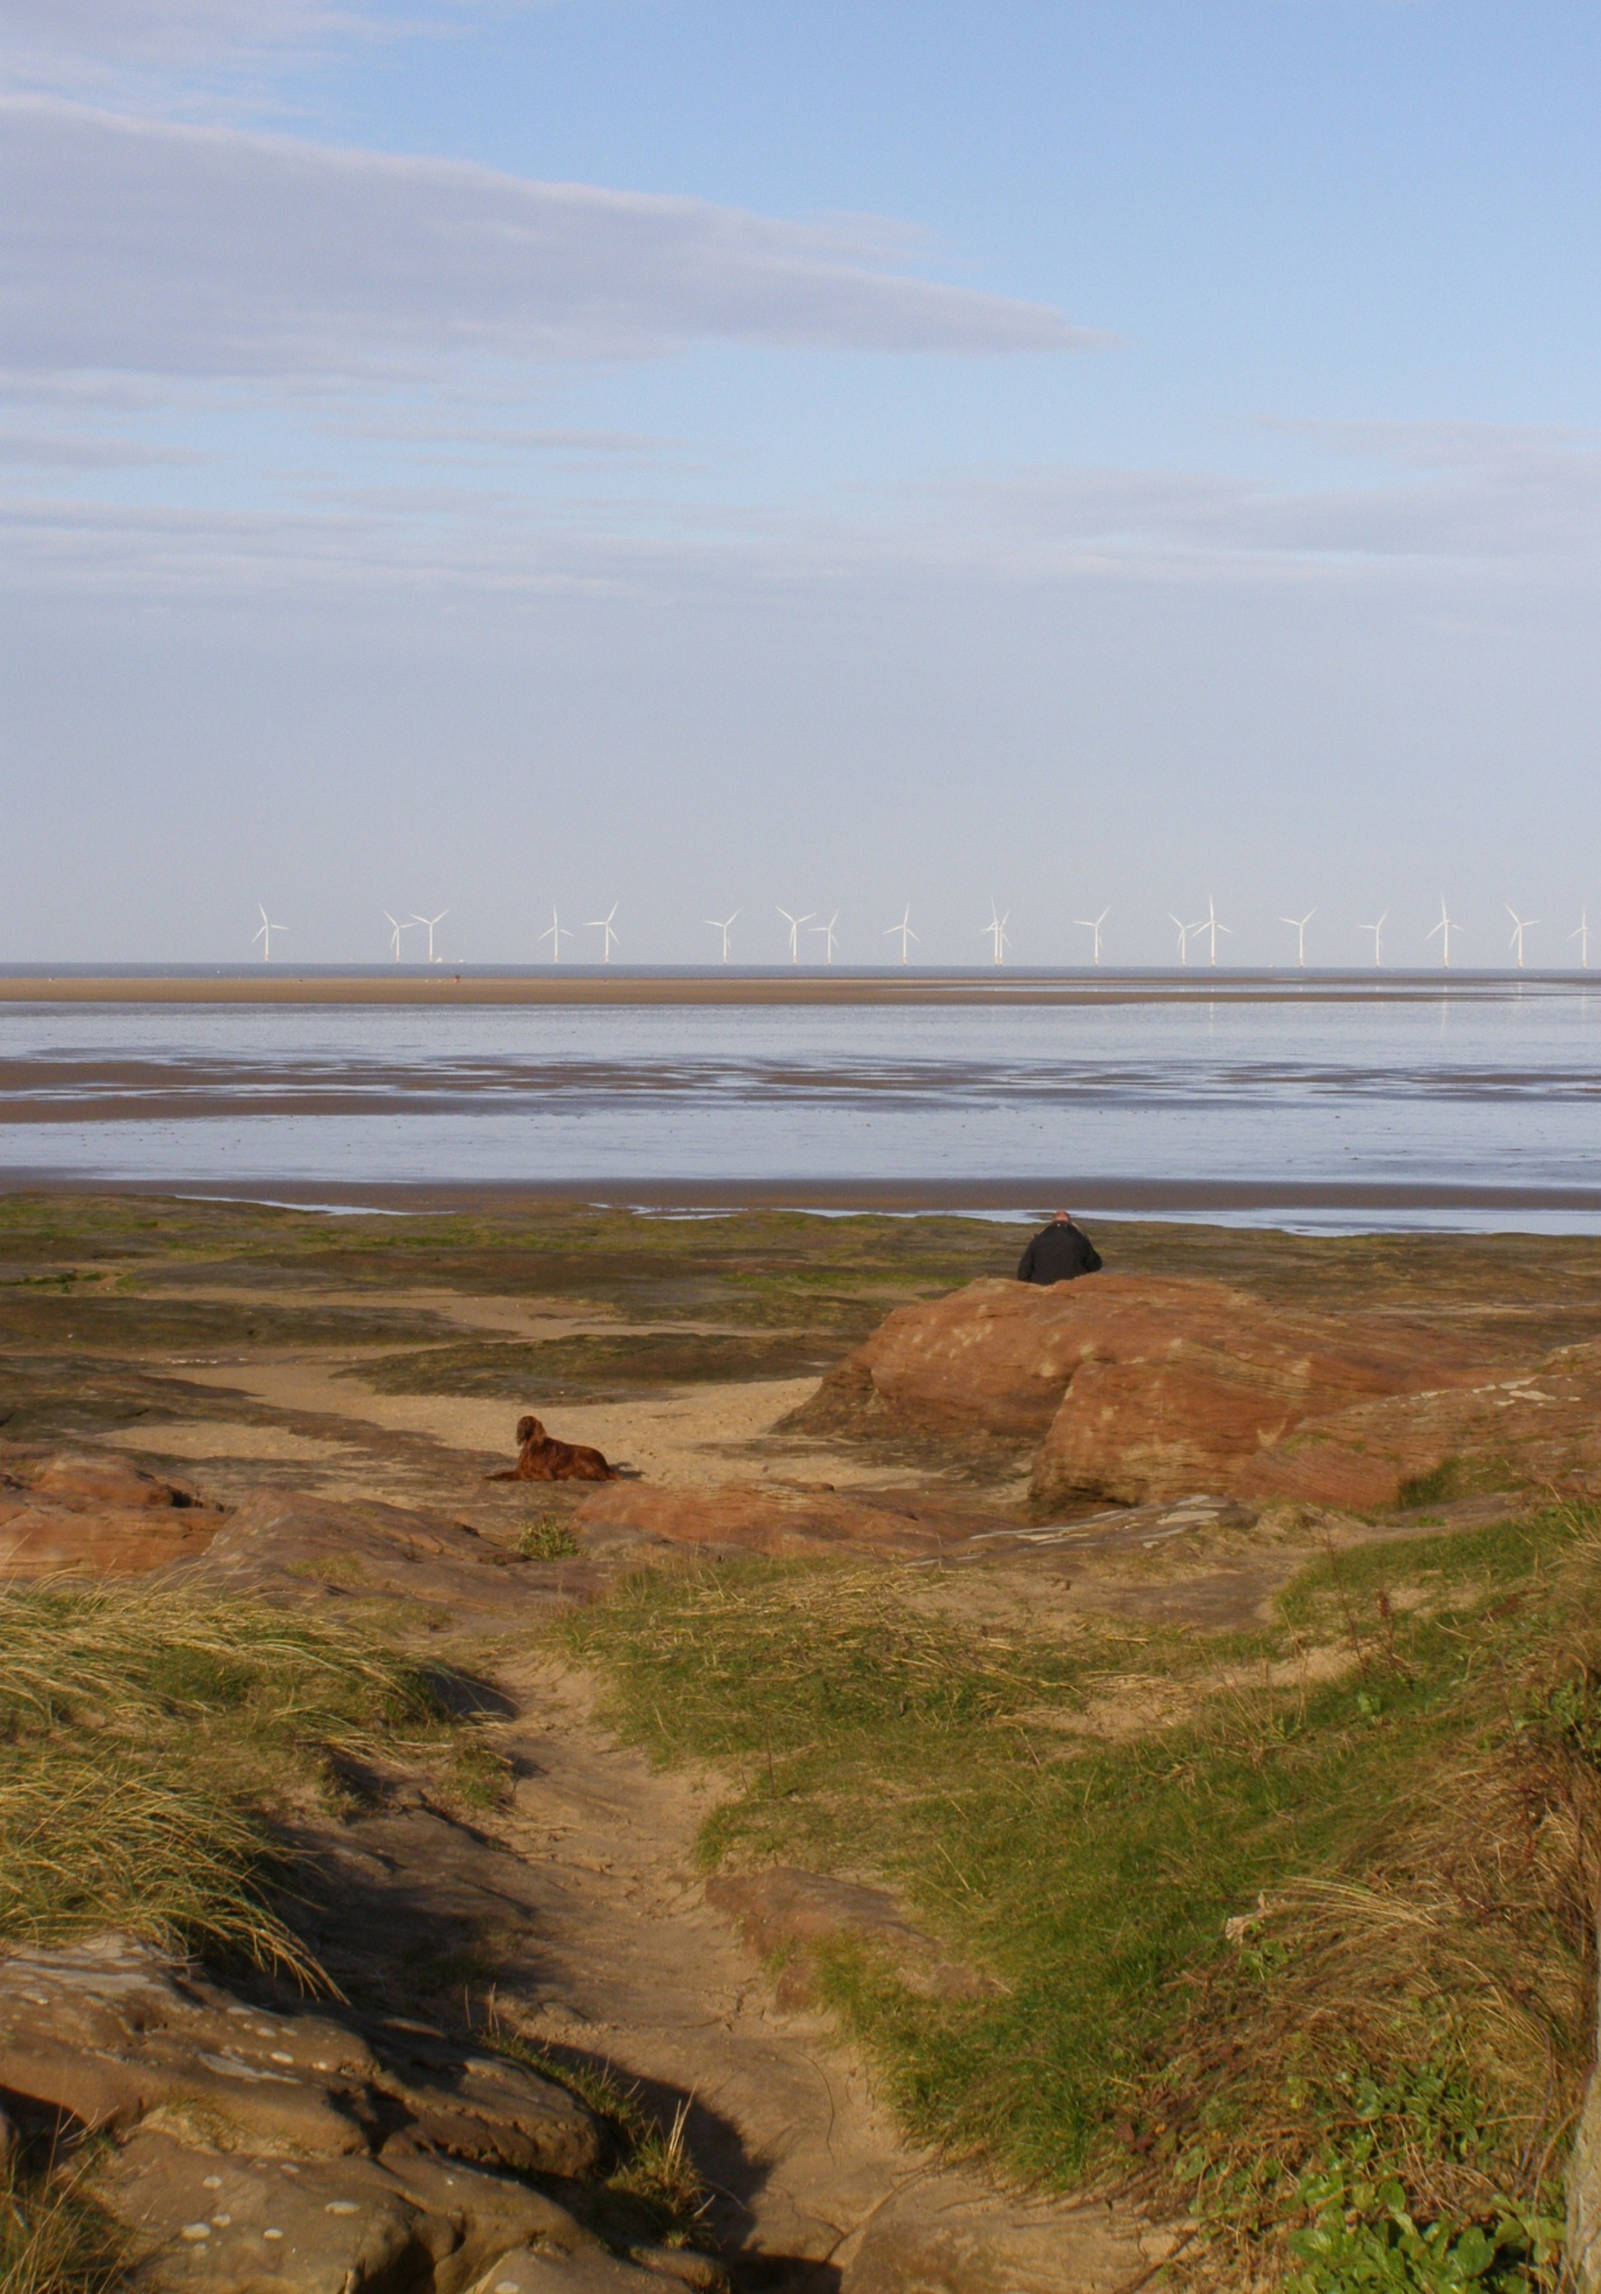
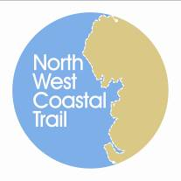
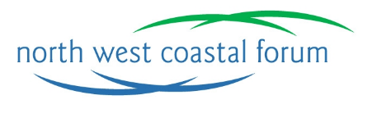
Event Summary
3rd December 2013
Imperial Hotel, Blackpool

Funding Coastal Access...

Contents

1. Introduction 2
2. Outputs of Workshop 3
2.1. County Region: Merseyside and Cheshire 4
2.2. County Region: Lancashire 7
2.3. County Region: Cumbria 11
2.4. Additional Comments 13
3. Conclusion and Next Steps 13
Appendix A: Event Programme 16
Appendix B: Delegates 17

Photo credits: Unless stated otherwise all photographic images used in this report are © Dave Willis mountainsportphoto.com
Front cover image © Caroline Salthouse

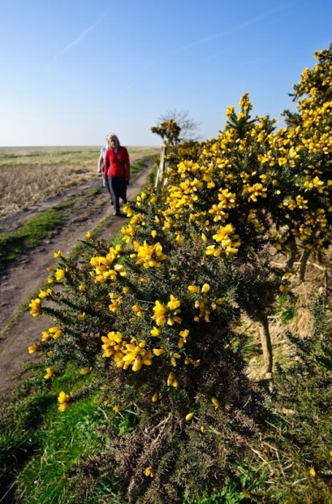
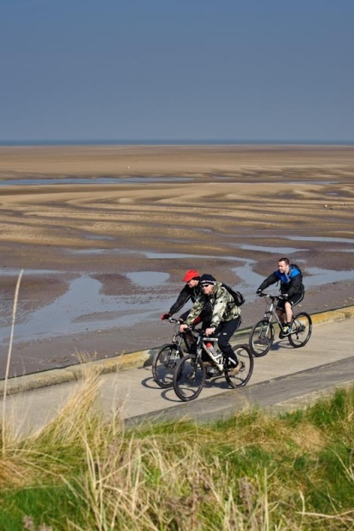
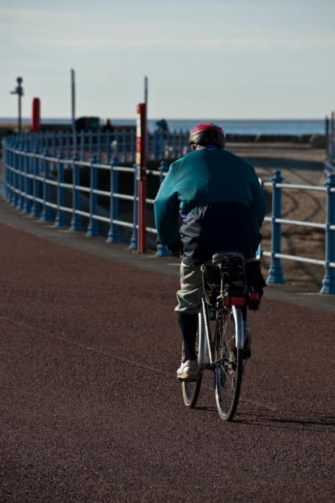
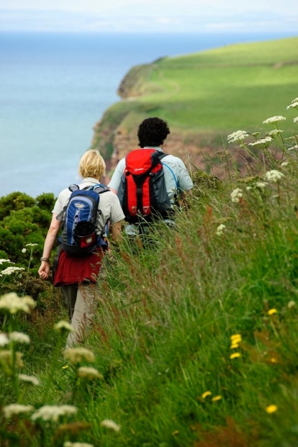

1. Introduction

The North West Coastal Trail Steering Group – a group established by the North West Coastal Forum to take forward an ambitious project to create a multi-use coastal trail from Chester to Carlisle linking together the natural, cultural and historical assets of the North West coast – held a one-day event on the 3rd December at the Imperial Hotel in Blackpool. The event was established to:
- Provide an update on funding opportunities for coastal access.
- Explore possibilities for collaborative bids to progress coastal access across administrative boundaries.
- Provide an opportunity to network and exchange information on coastal access improvements on the North West Coast
- Update delegates with the progress on national coastal access in Cumbria.
The event was also designed to explore and help answer the following questions:
Question 1. What funding sources are potentially available for the project?
- Have any funding pots been missed?
- What areas do they cover?
- What themes do they have?
- Are there any key constraints or previous experience to share?
Question 2. Are there any access bids already being developed?
- What are the current funding sources?
- What areas do they cover?
- What are the current themes?
- Which people/organisations are involved or taking a lead?
Question 3. Are there any ambitions for a new bid or several bids?
- What needs funding and from which source?
- Where is it and what geographic area should the bid cover?
- Which people/organisations should be involved?
The event was aimed at Local Authority Access Officers, elected members, Local Access Forum members and interest groups such as Ramblers, British Horse Society and Sustrans.
It took the form of a one day workshop with presentations and break out sessions designed to capture what is already taking place to further access on the North West coast and future opportunities and priorities for access.

2. Outputs of Workshop

The following section presents the results and recommendations from the questions considered for moving “Funding Coastal Access” forward within each county region. The results presented are from the following questions:
- Question 1. What funding sources are potentially available for the project?
- Question 2. Are there any access bids already being developed?
- Question 3. Are there any ambitions for a new bid or several bids?
The results are presented in an open format to enable amendments for any new updates and developments. Any updates or developments can be forwarded to the North West Coastal Forum Secretariat at info@nwcoastalforum.org.uk, see Section 3: Conclusion and Next Steps below.

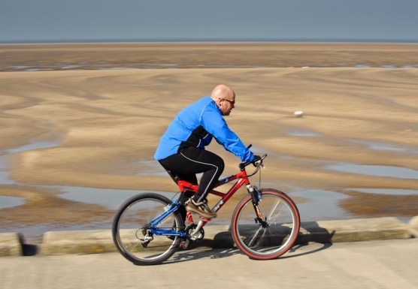
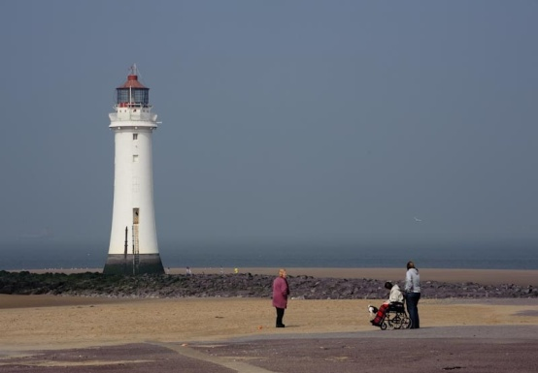
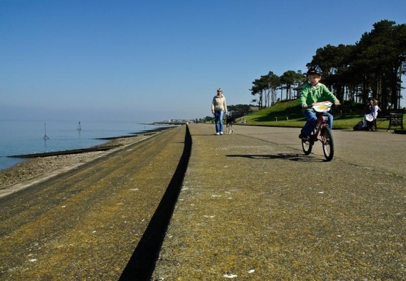

2.1. County Region: Merseyside and Cheshire

Question 1. Any other funding sources for Access?
Funding Source | Any particular themes e.g. heritage, health | Other information e.g. timescales funding limits, etc. | Any Experience to share
North West Wide
Paths for communities | Multi use paths  Access Paths | Low value bids | Difficult to bid for? (too many applicants)  Only new access  Need large/strong public right of way team
Health Budgets | Health walks | Potentially large amounts. Need health specialists | Useful in deprived areas?  Councils promote health message  NICE report – evidence!
Sport England  British Cycling | Activity, Sports,  Competition | Lottery linked | Need ‘sport’ element  Development plans
Other energy schemes | Access  Recreation | Future funding? | Major international projects
Nationwide
Department for Transport (DfT) links to communities | Community access | - | -
Environment Agency | Protecting waterways | - | -
United Utilities (e.g. funding community activities) | Access  Flood relief | - | -

Question 1 (cont). Any other funding sources for Access?
Funding Source | Any particular themes e.g. heritage, health | Other information e.g. timescales funding limits, etc. | Any Experience to share
Locally across the Nation
Local Sustainable Transport Fund (LSTF) | Walking/cycling | - | -
CABE | Visitor numbers/tourism | - | -
Arts Council | Visitor numbers/tourism  community engagement | -
European Regional Development Fund (ERDF) | - | - | -
Royal Society of the Protection of Birds (RSPB) | - | - | -
Nationwide (10 miles from a land fill site)
Waste Recycling Environmental Limited (WREN funding – land fill sites) | Access and conservation | - | -
Landfill tax | Access and conservation | - | -

Question 2. Access bids already being developed?
Funding Source? | Any particular themes? e.g. heritage health | Lead organization and others involved? | Any scope for new partners?
Liverpool and Halton
Section 106 Speke/Garston coastal reserve | - | - | -

Question 2 (cont). Access bids already being developed?
Funding Source? | Any particular themes? e.g. heritage health | Lead organization and others involved? | Any scope for new partners?
Liverpool
Access bids + community facilities | - | - | -
Sefton
Coastal footpath work in Sefton | - | - | -
Based on their own land holdings
Landowners – Peel, National Trust, Network Rail, Cllrs Neighbourhood | Improving local areas by residents | - | -
Lottery | Heritage, sports, Arts etc | - | -
Local Police – Property Act and Chief Constables Fund | Community security + access e.g. beach activities | - | -
Sport England | Access to sport and facilities | - | -
Section 106 + other development lands | Infrastructure/open space/access improvements | - | -

Question 3. Any ambitions for a new bid or several bids?
What needs funding? | Suggested funding sources, if any? | Suggested themes? e.g.heritage, health, muti-use etc.... | Which organisations should be involved
South Liverpool – Halton Liverpool airport area
Merseyway – Liverpool Airport up to Halton + links to the routes at Garston Docks | Tried [sp?] coastal comms  Trying [sp?] Peel + Developer contributors + National Trust | - | Tom from sailing club, NT, Peel Holdings, Ramblers

2.2. County Region: Lancashire

Question 1. Any other funding sources for Access?
Funding Source | Any particular themes e.g. heritage, health | Other information e.g. timescales funding limits, etc. | Any Experience to share
North West Wide
Paths for communities | Multi use paths  Access Paths | Low value bids | Difficult to bid for? (too many applicants)  Only new access  Need large/strong public right of way team
Health Budgets | Health walks | Potentially large amounts. Need health specialists | Useful in deprived areas?  Councils promote health message  NICE report – evidence!
Sport England  British Cycling | Activity, Sports,  Competition | Lottery linked | Need ‘sport’ element  Development plans
Other energy schemes | Access  Recreation | Future funding? | Major international projects
Nationwide
Department for Transport (DfT) links to communities | Community access | - | -
Environment Agency | Protecting waterways | - | -
United Utilities (e.g. funding community activities) | Access  Flood relief | - | -

Question 1 (cont). Any other funding sources for Access?
Funding Source | Any particular themes e.g. heritage, health | Other information e.g. timescales funding limits, etc. | Any Experience to share
Nationwide (10 miles from a land fill site)
Waste Recycling Environmental Limited (WREN funding – land fill sites) | Access and conservation | - | -
Landfill tax | Access and conservation | - | -
Locally across the Nation
Local Sustainable Transport Fund (LSTF) | Walking/cycling | - | -
CABE | Visitor numbers/tourism | - | -
Arts Council | Visitor numbers/tourism  community engagement | - | -
European Regional Development Fund (ERDF) | - | - | -
Royal Society of the Protection of Birds (RSPB) | - | - | -

Question 2. Access bids already being developed?
Funding Source? | Any particular themes? e.g. heritage, health | Lead organization and others involved? | Any scope for new partners?
Lytham
Land Registry (Lytham) Developer contribution (re 300m approx) | Coastal access link | Lead: Fylde BC (coastal authority)  Other: Friends of the Estuary (Lytham) | Natural England/Environment Agency

Question 2 (cont). Access bids already being developed?
Funding Source? | Any particular themes? e.g. heritage, health | Lead organization and others involved? | Any scope for new partners?
Lytham (cont)
Heritage Lottery and Coastal Communities re Mussels tanks/Scruples Lytham | Heritage  Public Access  Children’s Play Area | Civic Society  Park View  For You | -
Promenade – Fleetwood
Coastal communities (bid submitted round) | Environmental enhancement and job creation | Lead: Wyre BC  Other: Other partners, local businesses and voluntary groups | -
Fairhaven Lake
Heritage Lottery £2 million | Heritage - restore lake + infrastructure  - Japanese | Lead: Fylde BC  Other: RSPB  Ribble Cruising Club  Sea Scouts | -
Wyre coastal path
Lancashire Env. Fund/Private trusts | Environmental improvements/  Coastal access/  Ecology | Lead: Lancashire CC  Other: Groundwork  Wyre BC and private land owners | -

Question 3. Any ambitions for a new bid or several bids?
What needs funding? | Suggested funding sources? | Suggested themes? e.g. heritage, health, multi-use etc... | Which organisations should be involved?
West Lancashire and Hesketh Bank
Flood risk.  Access/Railway Bridge £3m.  Footpaths (Sefton interested) | Business, 106 and farmers - Fracking well, Booths, Agriculture  Heritage Lottery  Rivers  LTP  ERDF – Interreg  West Lancashire railway | Multi-use  Economy  Community link  Social  Heritage  Old Brick Works Shrimping  Weaving Mill  Canal | LA (LCC) /EA/RSPB/NE  Investors: Business  Housing 500 houses – private  Planning  Transportation  NFU
Lytham & St Annes
Island development regeneration | Developer  Sea defence (Defra) + match + health/heritage/arts  Coastal communities? | Multi-use  Tourism/hotel | Fylde BC  include planning + regeneration sections + engineering  + Princes Trust/businesses
Link whole of Fylde & Wyre coastline. Floodbanks Lytham/Warton to Preston
Missing links in coastal path from Preston to Fleetwood | Sea defence funding (Defra) + match heritage, art/grants health | Sea defence, Heritage, Arts and community/health | Landowners essential.  All local authorities. voluntary groups. EA/River Trusts.  RSPB / Natural England
Fleetwood Docks to Knott End
Coastal Defence Scheme Wyre Estuary. Fleetwood docks to Knott End | Sea defence  Defra  Health/Arts/Heritage | Sea defence  Heritage  Arts  Access/Community | Wyre BC

2.3. County Region: Cumbria

Question 1. Any other funding sources for Access?
Funding source? | Any particular themes? e.g. heritage, health etc... | Other information? E.g. timescales, funding limits etc.... | Any experience to share?
West Cumbria
NDA (Sellafield)  (Nuclear De-commissioning Authority) | Access  Recreation | Future funding? | -
North West Wide
Paths for communities | Multi use paths  Access Paths | Low value bids | Difficult to bid for? (too many applicants)  Only new access  Need large/strong public right of way team
Health Budgets | Health walks | Potentially large amounts. Need health specialists | Useful in deprived areas?  Councils promote health message  NICE report – evidence!
Sport England  British Cycling | Activity, Sports,  Competition | Lottery linked | Need ‘sport’ element  Development plans
Other energy schemes | Access  Recreation | Future funding? | Major international projects
Nationwide
Department for Transport (DfT) links communities | Community access | - | -
Environment Agency | Protecting waterways | - | -
United Utilities (e.g. funding community activities) | Access  Flood relief | - | -
Question 1 (cont). Any other funding sources for Access?
Funding source? | Any particular themes? e.g. heritage, health etc... | Other information? e.g. timescales, funding limits etc.... | Any experience to share?
Locally across the Nation
Local Sustainable Transport Fund (LSTF) | Walking/cycling | - | -
CABE | Visitor numbers/tourism | - | -
Arts Council | Visitor numbers/tourism  community engagement | -
European Regional Development Fund (ERDF) | - | - | -
Royal Society of the Protection of Birds (RSPB) | - | - | -
Nationwide (10 miles from a land fill site)
Waste Recycling Environmental Limited (WREN funding – land fill sites) | Access and conservation | - | -
Landfill tax | Access and conservation | - | -

Question 2. Access bids already being developed?
Funding Source? | Any particular themes? e.g. heritage health |  | Lead organization and others involved? |  | Any scope for new partners?
Morecambe Bay (Cumbria)
Heritage lottery + coastal communities | Visitor economy, jobs, tourism |  | - |  | -
Arnside Viaduct (Cumbria)
To be confirmed | Morecambe Bay Partnership |  | - |  | -
Question 3. Any ambitions for a new bid or several bids?
What needs funding? |  | Suggested funding sources, if any? |  | Suggested themes? e.g.heritage, health, muti-use etc.... |  | Which organisations should be involved
West Cumbria
Estuary crossing – Cumbria?  Comment: Network Rail + Natural England senior managers need to talk “strategically” to ensure viaducts are made accessible |  | - |  | All |  | CCC, NE, Network Rail

2.4. Additional Comments

In addition to answering the questions above participants made some additional comments. These are reproduced below:
- Pennine Bridleway was a high spec/over engineered. Do we need such high specs for trails?
- Public Rights of Way Teams often don’t have the resource to help develop coastal paths
- No money upfront from funders

3. Conclusion and Next Steps

Despite challenging economic times there is still a wide range of potential funding mechanisms for developing coastal access – on foot, on bike or by horse – and the associated infrastructure. Some of the funding sources identified may not have instantly obvious relevance to coastal access but thinking around the wider benefits opening up access can deliver, for example health and well being, natural or cultural heritage, community capacity building, job creation, can bring significant funding streams into play. Looking across borders – both local and national – and linking up with neighbouring authorities and other organisations may also provide access to new funding streams.
The North West Coastal Forum, through our longstanding ambition to create multi-use coastal access along the North West coast, has a role in helping to progress access improvements along the coast. To aid this it is intended that the tables above will be maintained as a ‘live’ information source and be updated at least quarterly.
We need your help to do this!
If you are developing – or wish to develop or be involved in developing – a bid please contact the North West Coastal Forum Secretariat at info@nwcoastalforum.org.uk with the following information (brief outline):
- Contact person (name, telephone, email and organisation). This will remain confidential and not be included on the publicly available document.
- Project name (or idea) and brief description including geographic area covered.
- Lead partner and other partners stating whether there is potential for others to be involved or not or ideas for who might lead/be involved.
- Possible additional benefits that could unlock funding such as health benefits, heritage interpretation, etc.
- Any identified funding source or sources or ideas for funding sources.
We are also maintaining a database of those wishing who would like to be put in touch with others in their area who come forward with access improvement ideas. If you would like to be included – your details will not be shared with anyone without checking with you first – please send your contact details and the geographic area / type of access project you might be interested in being involved in.

The North West Coastal Forum is a non-profit, multi-sector stakeholder partnership which aims to promote and deliver integrated coastal zone management for the long term sustainability of the north west’s coast. The North West Coastal Trail project helps to meet all of its underpinning objectives, but in particular the one relating to improved recreational opportunities and visitor experience. For more information on the Forum see www.nwcoastalforum.org.uk

Appendix A: Event Programme
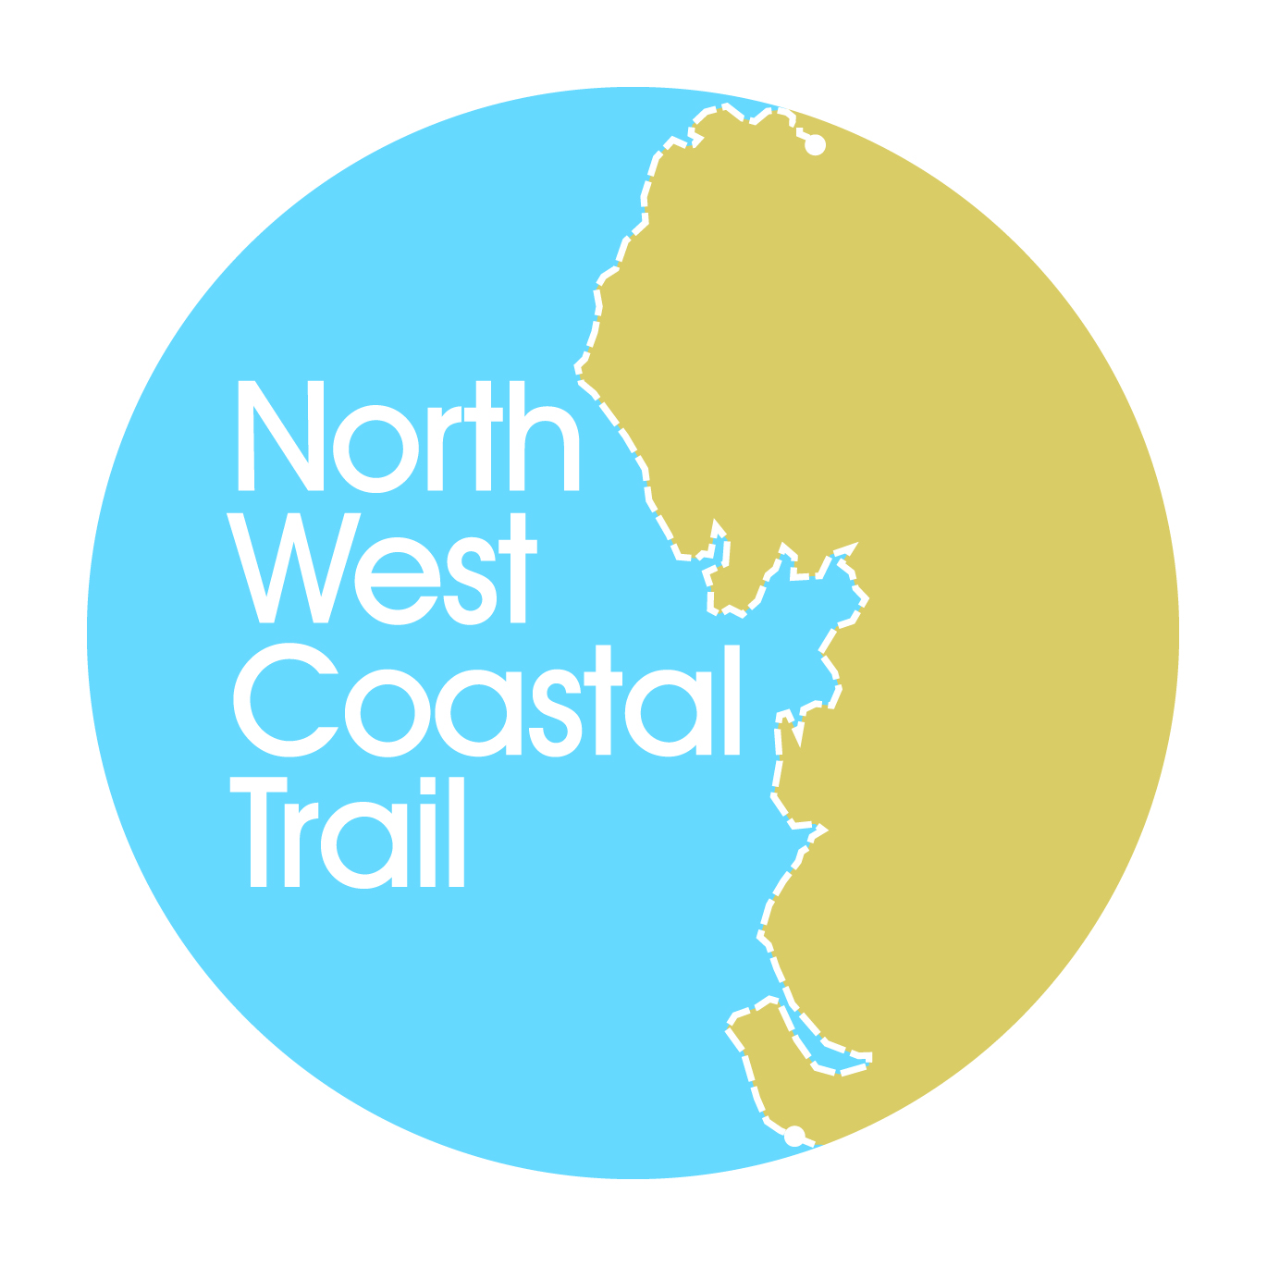
Funding Coastal Access

A North West Coastal Forum
Networking and Communications Event

3rd December 2013, Imperial Hotel, Blackpool

Programme

Conference Chair: Sue Kidd, Chair of the North West Coastal Trail Steering Group

10:00 Registration and refreshments

10:30 Welcome & ambition for the North West Coast
Sue Kidd, Conference Chair

10:45 Update on roll out of National Coastal Access
Danny Moores, Lead Advisor, England Coast Path Delivery Team (North West)

11:10 Heritage Lottery Fund
Maya Sharma, Development Officer, Heritage Lottery Fund North West

11:35 Coastal Communities Fund & relevant examples
Wil Woan, Big Lottery Fund

12:00 The INTERREG Programme – opportunities for 2014 - 2020
Caroline Salthouse, North West Coastal Forum

12:20 Discussion

12:30 Lunch

13:30 VISIT Sefton and West Lancashire Local Improvement Grants
Val Hough, Sustainable Visitor Travel Officer, Sefton Council

14:20 Coastal Defence Schemes and Access Opportunities
Carl Green, Head of Engineering, Wyre Borough Council

14:40 Discussion

14:50 Refreshments

15:10 Workshop exploring funding opportunities for improving coastal access across the North West

15:40 Feedback and summing up

16:00 Event Close

NB it may be necessary for reasons beyond the control of the organisers to alter the speakers, timing or venue of the event

Appendix B: Delegates
Funding Coastal Access
3rd December 2013, Imperial Hotel, Blackpool

Delegate List

Name | Organisation
Stephen Ball | Fylde Council
Janet Barton | Morecambe Bay Partnership
John Blackledge | Blackpool Borough Council
Alison Boden | Wyre Council
David Callan | Merseyside Local Access Forum
Nancy Corbin | Keep Britain Tidy
Neil Coventry | Liverpool City Council
James Daplyn | CAPITA Property & Infrastructure
Paul Drinnan | Fylde Council
Charles Ecroyd | Cumbria Local Access Forum
Frances Edwards | North West Coastal Forum
Neil Forbes | National Trust
David Gibson | Cumbria County Council
Carl Green | Wyre Council
Meg Green | Friends of the Estuary (Lytham)
Jim Green | Friends of the Estuary (Lytham)
Michael Helm | Lancashire Local Access Forum & The British Horse Society
Michelle Holroyd | Lancashire County Council
Val Hough | Sefton Council
Alice Irvine | SUSTRANS
Cllr Fred Jackson | Blackpool Council
Keith Johns | Ramblers Association
Sue Kidd | University of Liverpool
Dave McAleavy | Sefton Council
Danny Moores | Natural England
Clare Nolan-Barnes | Blackpool Borough Council
Michael Prescott | Lancashire Access Forum
Amy Ratcliffe | Blackpool Borough Council
Michael Ryan | Wyre Council
Caroline Salthouse | North West Coastal Forum
Maya Sharma | Heritage Lottery
Christine Smyth | Wirral Council
Karen Stringer | Wyre Council
Richard Toon | Lancashire Local Access Forum
Mrs R Tyson
Mr R Tyson
Wil Woan | Big Lottery
Tom Workman | Liverpool Sailing Club

